Cruciate ligament connects bone and bone. The role is to strengthen the stability of the joint, so as to avoid injury. When suffering from violence or non-physiological activities, ligaments are stretched beyond their tolerance, resulting in injury.

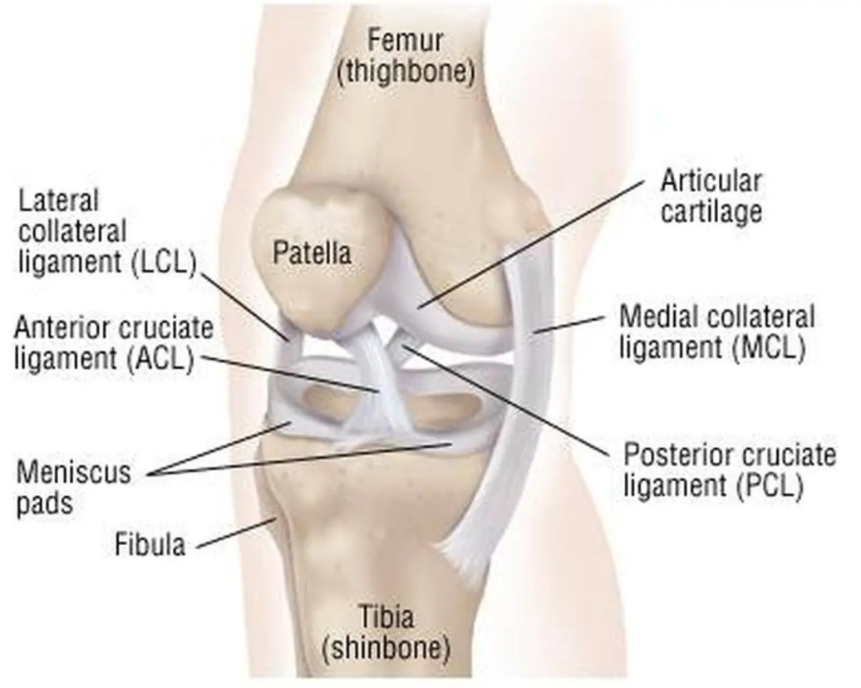

Cruciate ligament injury is very common in daily life. At present, many ligament reconstruction operations are based on the experience of doctors, and errors are inevitable. Extraction and reconstruction of cruciate ligament insertion is very important, which can help doctors to analyze and predict before surgery, and improve the success rate of surgery.

First, we use U-Net network structure to extract bone and cruciate ligament from MRI.

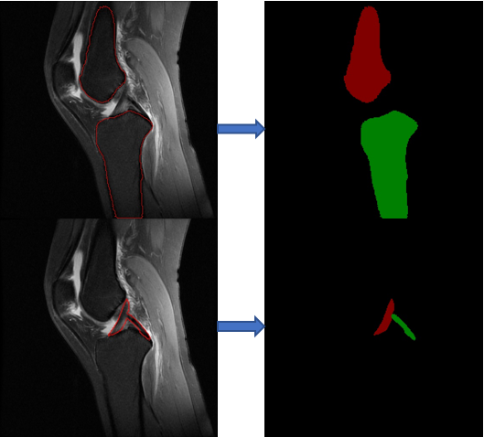

Then we used OpenCV to extract the femur and tibia contour, binary and fill operation, and reconstruct with VTK. We can reconstruct the knee joint bone that contains only the shell.

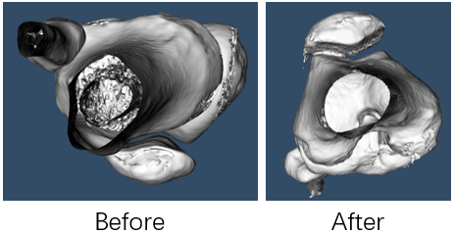

Next, we need to reconstruct the bone in MRI. The bone in MRI is used as a bridge to connect the ligament in MRI and the femur and tibia in CT.

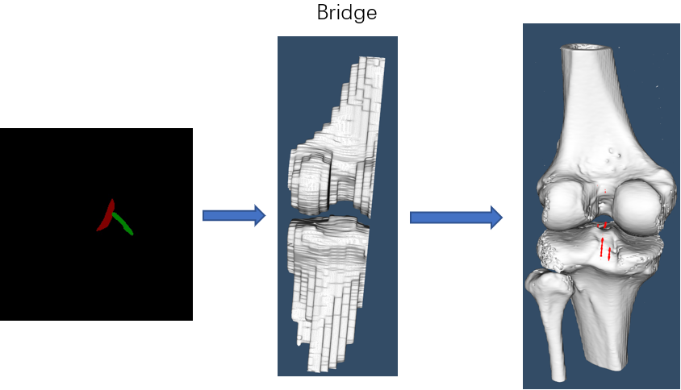

Next, we need to register the bone in MRI with that in CT. In this way, we can map the ligament insertion information in MRI to the bone in CT.

In order to make the patient "forgetful", we need to reconstruct the ligament for 30 °、 60 ° and upright testing.

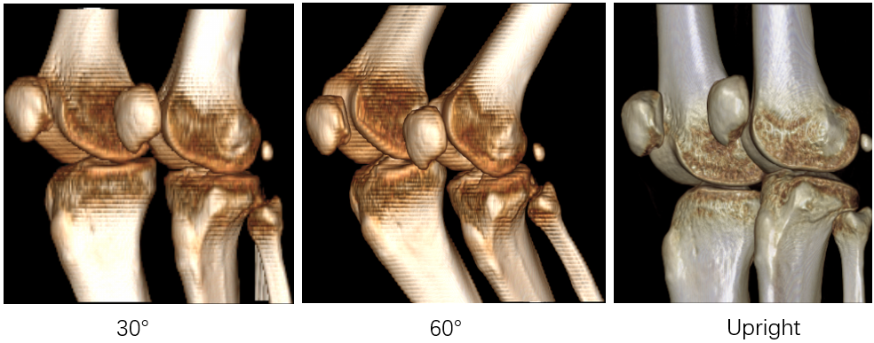

Finally, we will use 3D printing technology to obtain the knee bone entity. Then, the reconstructed insertion position was found on the knee bone.